 |  | 
SESLHD Nursing and Midwifery 2024
Order form - Strengths, Positive Thoughts & Affirmation cards
Please complete all sections, scan and return to SESLHD-NursingandMidwifery@health.nsw.gov.au
First Name
Surname
Local Health District
Facility / Site
Contact Number
Email Address
Number of sets of cards required
Date funds transferred
Transfer receipt number /image of receipt
Bank transfer details: Westpac Bank
BSB: 032 099
Account Number: 521557
Account Name: South Eastern Sydney Local Health District RFA
Reference: ‘Initial, Last Name – Heart of Caring cards
For example: J Brown – Heart of Caring- cards)
Card Cost $25 AUD + $10 Postage AUD (Postage fee for outside South Eastern Sydney Local Health District) (incl. GST)

Please note – No refunds are payable
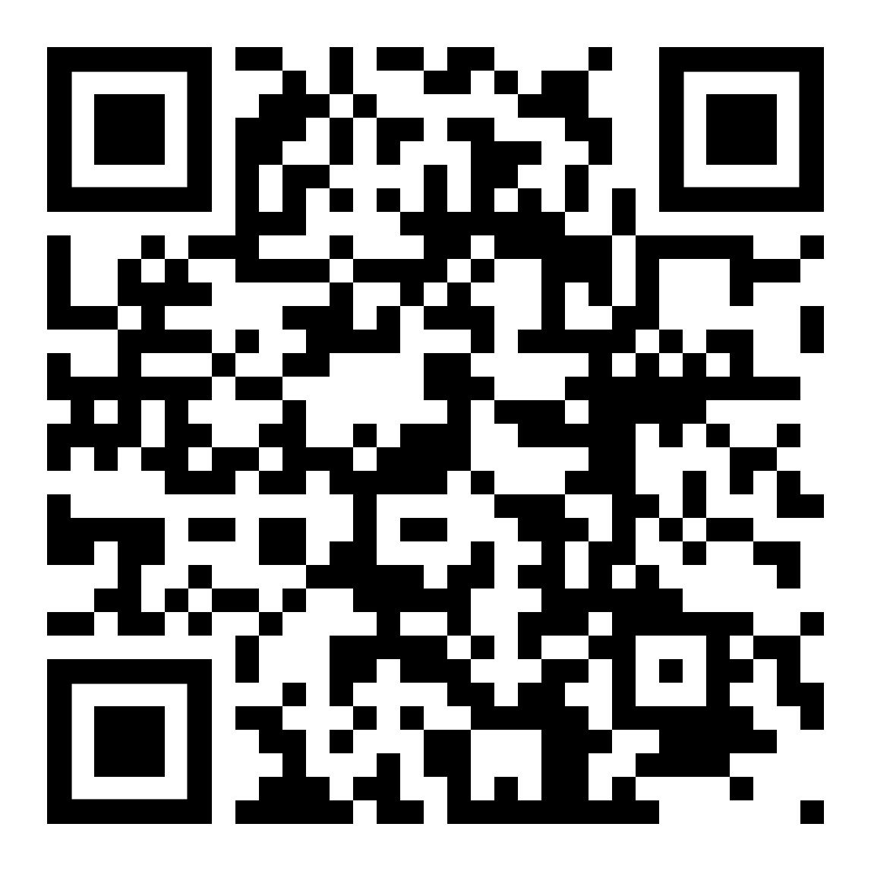
Heart of Caring Resources SESLHD Internet site

