1. The upper end of the humerus:
Select one:
a. Has the capsular ligament of the shoulder joint attached to the whole of the anatomical neck
b. Has the subscapularis attached to the greater tuberosity
c. Is the growing end of the humerus Correct. Moore 6th Edition pg 676, 705 table 6.6
- d. Has teres major attached to the floor of the bicipital groove

2. The skin at the tip of the index finger is supplied by:
Select one:
a. The radial nerve only
b. The ulnar nerve only
c. The median nerve only Correct. Moore 6th Edition pg 695 figure 6.19

d. The radial and median nerves

3. The clavicle
Select one:
a. Articulates laterally with the coracoid via the coracoclavicular ligament
b. Forms part of the apex of the axilla Correct. Moore 6th Edition pg 713
c. Is convex anteriorly throughout its entire length

d. Is crossed in its middle third by the subclavian vein

4. The radius
Select one:
a. Provides insertion for the brachialis muscle at the radial tubercle (ulnar tuberosity)
b. Provides insertion for brachioradialis at the tip of the styloid process (close to the styloid process)
c. Articulates with the trochlea of the humerus in a synovial ball and socket joint (articulates with capitulum)
d. Has Lister’s tubercle on its posterior aspect Correct. Moore 6th Edition pg 678 "dorsal tubercle of the radius

Lister's tubercle or dorsal tubercle of radius is a bony prominence located at the distal end of the radius, palpable on the dorsum of the wrist. Lister's tubercle serves as a pulley for the tendon of extensor pollicis longus, which wraps around the medial side and takes a 45 degree turn.

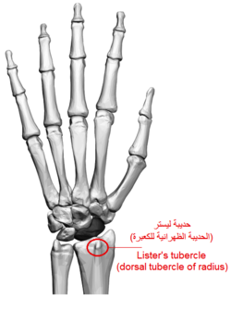

5. Regarding lymphatic drainage of the arm:
Select one:
a. Deep lymphatics are more numerous than superficial
b. Deep lymphatics accompany the basilic and cephalic veins
c. Most drainage from the palm passes to the volar aspect of the hand Incorrect. Moore 6th Edition pg 692-693, fig 6.17

d. Superficial lymphatics accompany arteries

(correct answer states b…but superficial lymphatics accompany the basilica and cephalic veins. Deep lymphatics accompany major deep veins)

6. With respect to the carpus:
Select one:
a. The intercarpal synovial space is usually continuous with the wrist joint
b. The scaphoid is the only carpal bone which articulates with the radius
c. The intercarpal joints share one continuous synovial space Correct. Moore 6th Edition pg 680 "carpals glide on each other"

d. The proximal row consists of scaphoid, lunate and trapezium

7. The lunate (B) articulates with all of the following EXCEPT:
Select one:
a. Triquetral (C)
b. Trapezoid (F) Correct. Moore 6th Edition pg 679 Figure 6.9
c. Scaphoid (A)

d. Capitate (G)

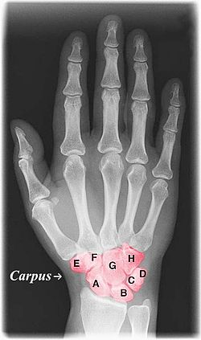

8. Regarding the cutaneous nerve supply to arm and forearm
Select one:
a. C4/5/6 /T1 supply the majority of the arm
b. Branches of the brachial plexus supply the arm and forearm Correct. Moore 6th Edition pg 694 figure 6.18
c. C3/4 supply pectoral and upper shoulder

d. C8 supplies the middle finger

9. The posterior cutaneous nerve of the forearm is a branch of which nerve?
Select one:
a. Long thoracic nerve
b. Radial nerve Correct. Moore 6th Edition pg 695, fig 6.19
c. Ulnar nerve

d. Median nerve

- Cutaneous innervation by the radial nerve is provided by the following nerve branches:
- Posterior cutaneous nerve of arm (originates in axilla)
- Inferior lateral cutaneous nerve of arm (originates in arm)
- Posterior cutaneous nerve of forearm (originates in arm)

The superficial branch of the radial nerve provides sensory innervation to much of the back of the hand, including the web of skin between the thumb and index finger.

10. Which of the following bones is attached to flexor and extensor retinaculum?
Select one:
a. hamate Correct. Moore 6th Edition pg 690 figure 6.14D
b. scaphoid
c. trapezium

d. pisiform

Wrong answer on HETI. Should be pisiform

The extensor retinaculum is strong oblique fibrous band in the fascia of the distal forearm. It attaches to the lateral border of the radius and crosses to attach to the triquetral and pisiform bones of the wrist. As it crosses the posterior surface of the radius it binds to elevations on the bone and forms six tunnels that transmit tendons beneath it and into the wrist and hand. These tunnels are lined with synovial tendon sheaths that protect the extensor tendons from excess friction.

